Source: https://www.npr.org/2020/03/26/821457551/whats-inside-the-senate-s-2-trillion-coronavirus-aid-package

What's Inside the Senate's $2 Trillion Coronavirus Aid Package
March 26, 20205:34 PM ET

Kelsey Snell

How The $2 Trillion Breaks Down

The CARES Act provides relief to several groups impacted by the coronavirus pandemic.
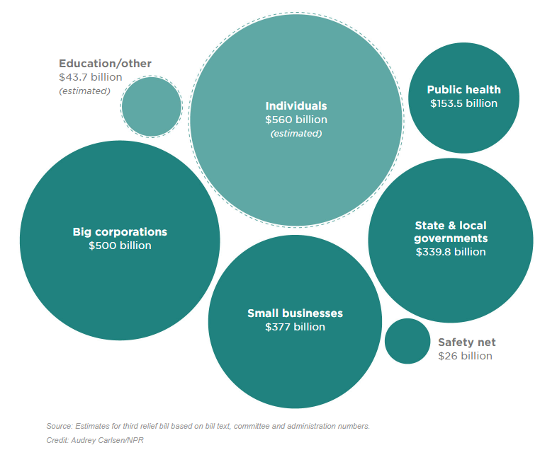
The Senate has passed a roughly $2 trillion coronavirus response bill intended to speed relief across the American economy. This is the third aid package from Congress and is meant to keep businesses and individuals afloat during an unprecedented freeze on the majority of American life.
Senate Majority Leader Mitch McConnell, R-Ky., described the legislation, known as the CARES Act, as necessary emergency relief and vowed to put partisanship aside to get it done.
"No economic policy can fully end the hardship so long as the public health requires that we put so much of our commerce on ice," McConnell said in a speech on the Senate floor on Wednesday. "This isn't even a stimulus package. It is emergency relief. Emergency relief. That's what this is."
There are seven main groups that would see the widest-reaching impacts: individuals, small businesses, big corporations, hospitals and public health, federal safety net, state and local governments, and education.
Here's what each group can expect if this bill becomes law.
Note: The legislation was released late Wednesday night, and official cost estimates have not yet been completed. In some cases, Congress allocated dollar figures for specific programs. The official expected costs of other programs are not yet available. This story includes some figures that are based on administration and congressional estimates.
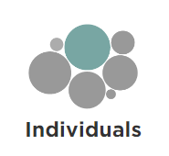
The bill includes several elements aimed at helping keep people engaged in the economy. That means direct cash for many, plus expanded unemployment benefits and new rules for things like filing your taxes and making retirement contributions.
Cash payments: Estimated to total $300 billion. Most individuals earning less than $75,000 can expect a one-time cash payment of $1,200. Married couples would each receive a check and families would get $500 per child. That means a family of four earning less than $150,000 can expect $3,400.
The checks start to phase down after that and disappear completely for people making more than $99,000 and couples making more than $198,000.

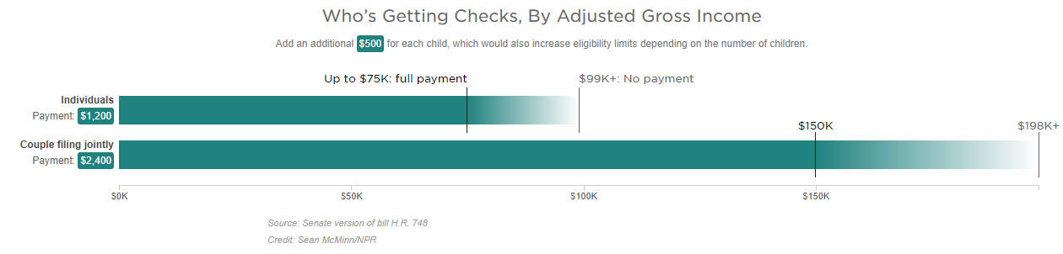
The cash payments are based on either your 2018 or 2019 tax filings. People who receive Social Security benefits but don't file tax return are still eligible, too. They don't need to file taxes; their checks will be based on information provided by the Social Security Administration.
Extra unemployment payments: The $260 billion estimated cost is subject to change based on the number of people filing for unemployment.
The bill makes major changes to unemployment assistance, increasing the benefits and broadening who is eligible. States will still continue to pay unemployment to people who qualify. That amount varies state by state, as does the amount of time people are allowed to claim it.
This bill adds $600 per week from the federal government on top of whatever base amount a worker receives from the state. That boosted payment will last for four months.
For example, if an out-of-work person is receiving the national average of about $340 per week, under the new federal program their take-home pay will be $940.
The legislation also adds 13 weeks of unemployment insurance. People nearing the maximum number of weeks allowed by their state would get an extension. New filers would also be allowed to collect the benefits for the longer period.
Gig workers and freelancers: Typically, self-employed people, freelancers and contractors can't apply for unemployment. This bill creates a new, temporary Pandemic Unemployment Assistance program through the end of this year to help people who lose work as a direct result of the public health emergency.
Tax returns: Some people have not filed their 2019 tax returns, but that's OK. The filing deadline has been extended to July 15. The IRS also says that people who have filed or plan to can still expect to receive a refund if they are owed one.
Student loans: Employers can provide up to $5,250 in tax-free student loan repayment benefits. That means an employer could contribute to loan payments and workers wouldn't have to include that money as income.
Insurance coverage: The bill requires all private insurance plans to cover COVID-19 treatments and vaccine and makes all coronavirus tests free.
The main features for small businesses are emergency grants and a forgivable loan program for companies with 500 or fewer employees. There are also changes to rules for expenses and deductions meant to make it easier for companies to keep employees on the payroll and stay open in the near-term.
Emergency grants: The bill provides $10 billion for grants of up to $10,000 to provide emergency funds for small businesses to cover immediate operating costs.
Forgivable loans: There is $350 billion allocated for the Small Business Administration to provide loans of up to $10 million per business. Any portion of that loan used to maintain payroll, keep workers on the books or pay for rent, mortgage and existing debt could be forgiven, provided workers stay employed through the end of June.
Relief for existing loans: There is $17 billion to cover six months of payments for small businesses already using SBA loans.
The bill sets aside roughly $500 billion in loans and other money for big corporations. These companies will have to pay the government back and will be subject to public disclosures and other requirements.
Airlines: About $58 billion is allocated to help airlines stay open. One portion of that money is set aside to help cover employee wages, salaries and benefits divided up as up to $25 billion for passenger air carriers, up to $4 billion for cargo air carriers, and up to $3 billion for airline contractors.
Stock buyback ban: Any company receiving a loan under the program is barred from making stock buybacks for the term of the loan plus one year.
Reporting requirements: All loans, their terms and any investments or other assistance provided by the government must be publicly disclosed.
Oversight: The bill creates a special inspector general to oversee pandemic recovery. That person, along with a special committee, would provide oversight of all loans and other uses of taxpayer dollars.
No benefit for Trump: The president, vice president, members of the Cabinet and members of Congress are barred from benefiting from the money carved out for corporations. That also extends to the "spouse, child, son-in-law or daughter-in-law."
All businesses: The bill establishes a fully refundable tax credit for businesses of all size that are closed or distressed to help them keep workers on the payroll. The goal is to get those employees hired back or put on paid furlough to make sure they have jobs to return to. The credit covers to 50 percent of payroll on the first $10,000 of compensation, including health benefits, for each employee.
For employers with more than 100 full-time employees, the credit is for wages paid to employees when they are not providing services because of the coronavirus. Eligible employers with 100 or fewer full-time employees could use the deduction even if they aren't closed.

Public Health
Lawmakers want to supplement community and private health systems to help meet the influx of new patients.
Hospitals: There is $100 billion for hospitals responding to the coronavirus.
Community health centers: The bill provides $1.32 billion in immediate additional funding for community centers that provide health care services for roughly 28 million people.
Drug access: There is $11 billion for diagnostics, treatments and vaccines. The bill also includes $80 million for the Food and Drug Administration to prioritize and expedite approval of new drugs.
Centers for Disease Control and Prevention: CDC programs and response efforts are getting $4.3 billion.
Veterans' health care: There is $20 billion set aside for veterans.
Telehealth: The bill reauthorizes a critical telehealth program to extend the reach of virtual doctors appointments.
Medicine and supplies: The bill gives $16 billion to the Strategic National Stockpile to increase availability of equipment, including ventilators and masks. It also boosts hiring for vital health care jobs during the public health crisis and speeds the development of a vaccine, treatments and faster diagnostic.

Safety Net
This is the second wave of funding for major food security programs.
Child nutrition: There is $8.8 billion to give schools more flexibility to provide meals for students.
Food stamps: $15.5 billion is going to the Supplemental Nutrition Assistance Program, also known as SNAP. The money will help cover the expected cost of new applications to the program as a result of the coronavirus.
American Indian reservations, Puerto Rico, Northern Mariana Islands and American Samoa all get additional funds and access to federal nutrition programs.
Food banks: There is $450 million more for food banks and other community food distribution programs.

State and Local Governments
The legislation designates $339.8 billion for programs that will go to state and local governments. It is divided up to put $274 billion toward specific COVID-19 response efforts, including $150 billion in direct aid for those state and local governments running out of cash because of a high number of cases.
It also includes $5 billion for Community Development Block Grants, $13 billion for K-12 schools, $14 billion for higher education and $5.3 billion for programs for children and families, including immediate assistance to child-care centers.

Education/Other

The bill includes relief for college students and graduates with outstanding federal student debt.
Temporary student loan relief: All loan and interest payments would be deferred through Sept. 30 without penalty to the borrower for all federally owned student loans.
Work-study funds: It allows schools to turn unused work-study funds into supplemental grants and continue paying work-study wages while schools are suspended.
Students who are forced to drop out: Students who drop out of school as a result of the coronavirus wouldn't have that time away from school deducted from their lifetime limits on subsidized loan and Pell Grant eligibility. Those students would also not be asked to pay back any grants or other aid they've already received.
Other programs: There is a very long list of other areas receiving funding including arts programs, universities and other institutions.

